REPUBLIC OF RWANDA  MINISTRY OF ENVIRONMENT | B P: 898, Kigali  Tel: +250 252575813  E-mail:bulletin@meteorwanda.gov.rw  Website: www.meteorwanda.gov.rw

Climatological BulletinN°17/2019: 11th–20th July 2019

Issued on 12th July 2019

Highlights:
  - The overall cumulative rainfall; dekad1 July 2019 was observed to be above normal over the Northern, Western and Southern Province as compared with the LTM (Long-Term Mean) due to weakening of pressure that led to convergence of wind over the region while the rest of the country received very light rainfall.
  - The soil moisture content in third dekad of June and dekad 1 of July kept on decreasing especially over the East, Kigali City and constant over South, North and West due to the rainfall received in dekad1.
  - The rainfall during second dekad of July 2019; we expect dry conditions over most parts of the country and light rainfall over Western and Northern Provinces in the areas near Lake Kivu and volcanoes.
- Introduction
The 1st dekad of July 2019; shows that the cumulative rainfall over the South, North and Western resulted from the rainfall received within first 10 days of July due do convergence winds near located between RDC and Rwanda and between Rwanda and Victoria Lake.

- The table and histogram below indicates the rainfall recorded during dekad1 June 2019:
Ubupimiro | 1-10_Nyakanga_2019 | 1_10_Nyakanga
Kigali | 0 | 1,6
Rusizi | 15,6 | 3,6
Rubavu | 21,7 | 6,6
Nyamagabe | 10 | 6,1
Ngoma | 4 | 1,3
Gicumbi | 9,9 | 4,2
Busogo | 7,5 | 7,2
Bugarama | 30,4 | 6,3
Musanze | 16,9 | 2,8
Gitega | 0 | 0
Rubengera | 2,2 | 4,5
Byimana | 0 | 5,5
Kawangire | 0 | 1,7
Nyagatare | 0,3 | 1,3
Cumulative rainfall (in mm) recorded at different stations

^{Table1}

- Rainfall analysis: The maps“Map 1 and 2” below show the cumulative rainfall recorded during dekad1 July 2019 and the cumulative rainfall for the same period in Long Term Mean.
Map1: Total Rainfall (mm): dekad1 July 2019 Map2: Long Term Average Rainfall (mm): dekad1 July LTM

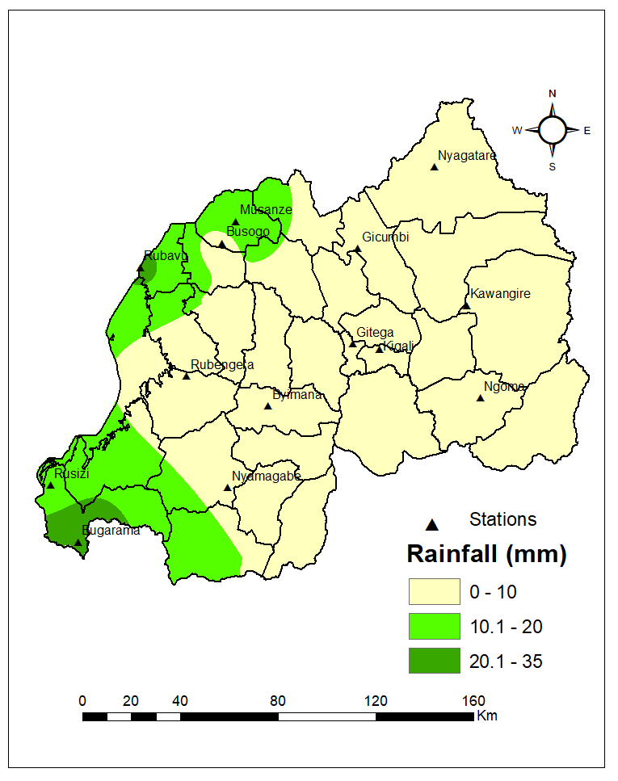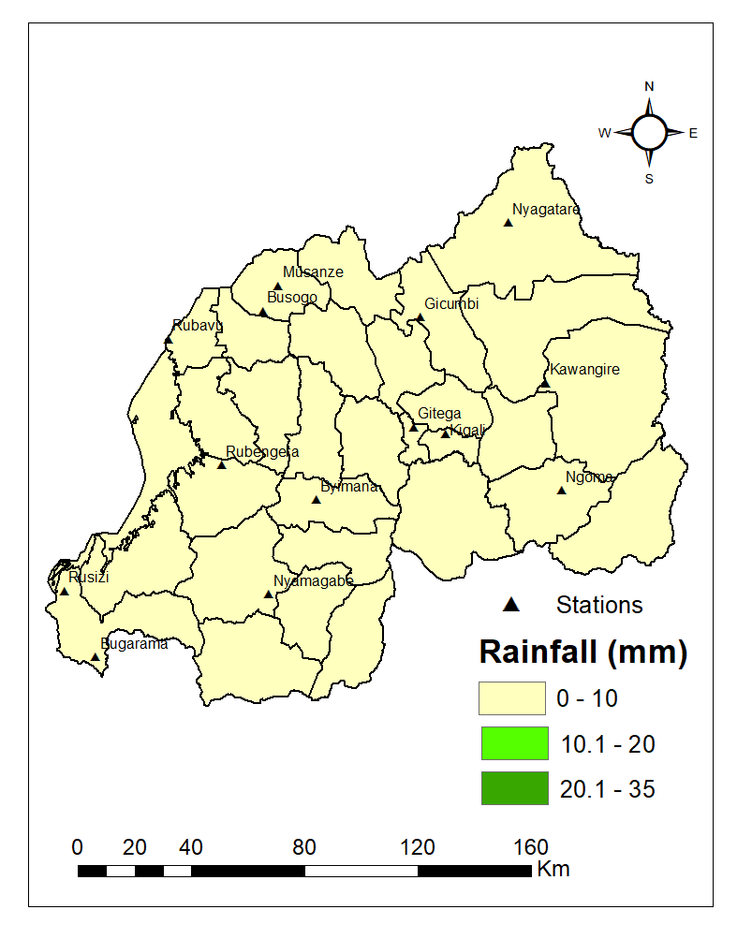
Map 1 Map 2

- Detailed observed rainfall during the dekad2 June_2019

During the dekad1 July 2019; the cumulative rainfall was observed to be above normal over the Northern, Western and Southern Province as compared with the LTM (Long-Term Mean) while the rest of the country received very light rainfall (see Map1&2).

- Agricultural impact
- Satellite images : Soil Moisture Index (MI)
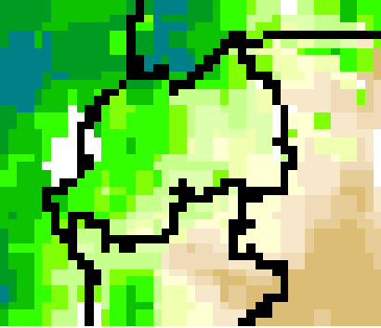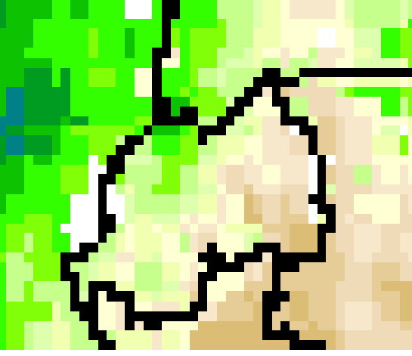
Map3: June .2019 dekad3 Map4: July .2019 dekad3

Comparing the dekad3 June 2019 to dekad1 July 2019 satellite derived moisture index; kept on showing dry soil increasingly as a result of the dry weather condition observed especially in South, Central and East. (see Map3&4).

- Rainfall forecast for dekad2 July 2019 from 11 to 20th July 2019

The rainfall during the second dekad of July 2019; we expect light to moderate rainfall in the first days of dekad two (within the first week). Dry conditions are expected towards the end of the first week to the second week of dekad two July 2019.

• Kigali City: is expected to receive rainfall amount ranging up to 10mm within coming two weeks.
• Eastern Province: is expected to receive rainfall amount ranging up to 10mm within coming two weeks.
• Southern Province: is expected to receive rainfall amount ranging up to 10mm within coming two weeks.
• Western Province: is expected to receive rainfall amount ranging from 10mm to 15mm within coming two weeks.
• Northern Province: is expected to receive rainfall amount ranging from 10mm to 15mm within coming two weeks.

Amount of rain (in mm) expected for the coming two weeks:

Map7: July 2019, 11th to 18th Map8: from July 2019, 18th to 25th
N.B: This forecast should be used in conjunction with the daily (24-hour), Three (3), Five (5) and Seven (7) days forecasts issued by the Rwanda Meteorology Agency (Meteo Rwanda)

