Comparison of Rainfall performance during October 2017 and Long term mean of the country

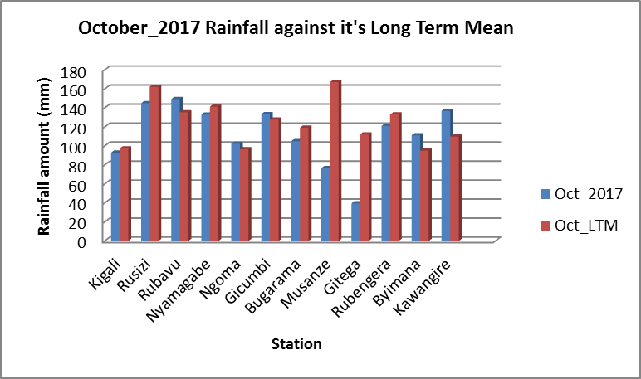

- REVIEW OF THE WEATHER DURING OCTOBER 2017
Most parts of the country were generally wet during the month of October 2017. Several parts of the country recorded good amount of rainfall compared to the October Long-Term Mean (LTM), though in some localized places the rainfall was below the LTM in parts of Musanze and Gitega.
- PREVAILING SYNOPTIC CONDITIONS DURING SEPTEMBER 2017
The Sea Surface Temperature (SST) anomaly during the period 03 September – September 30, 2017 showed that over central equatorial Pacific Ocean stretching towards the eastern equatorial Pacific region (Niño 4 to Niño 1&2 areas), cooler than average to near average SST anomaly was observed, with the area stretching from central towards western equatorial Pacific Ocean recording warmer than average SST, however this situation still currently presents a neutral El Niño Southern Oscillation (ENSO) phase, however models show an increased likelihood of Negative ENSO towards the end of the year 2017. Near average to cooler than average SST conditions dominated eastern side of equatorial Indian Ocean with much of the central to western equatorial Indian Ocean experiencing warmer to near average SST. This pattern has presented a positive phase of the IOD. 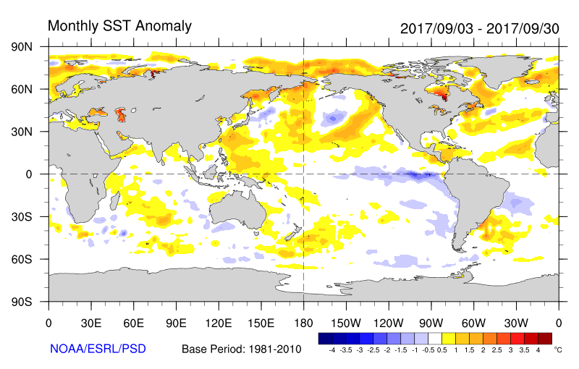
Sea surface temperatures for the period 03 September to 30 September 2017 (Source: NOAA/ESRL/PSD)

- WEATHER OUTLOOK FORECAST FOR NOVEMBER 2017
The forecast indicates that most parts of the country are likely to experience near-average to above normal rainfall during the Month of November 2017.
In the month of November 2017, much of the southern sector of the country is likely to experience near average (normal) rainfall. Rainfall amount less than 150mm is likely to be experienced in, southern sector of Rwanda. Northern sector of Rwanda rainfall is expected to be near average to above average rainfall greater than 100 mm on monthly accumulation.

The eastern, central, southern and south western regions are expected to receive near average (normal) rainfall.

The northern and north western regions are expected to receive near average to above normal rain fall.

N.B This outlook is supplimented by daily updates of different timescales (24-hours, 5-days and 10-days forecasts) and advisories issued by Rwanda Meteorology Agency.

Done on 3rd November, 2017

